Step 1: Importing the Required Libraries
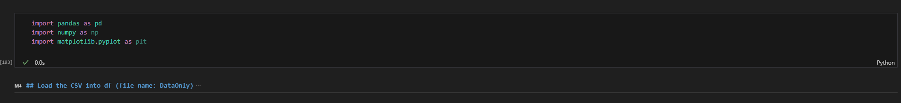
The analysis begins by importing the key Python libraries needed to load, analyse, and visualise the dataset.
Step 2: Loading and Inspecting the Dataset
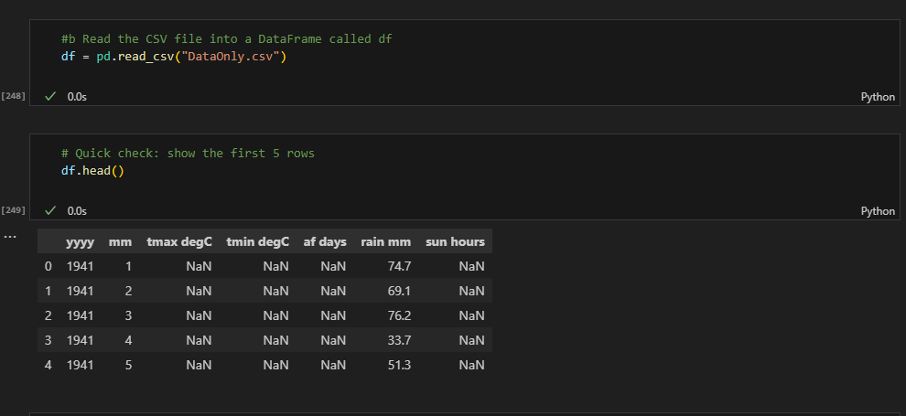
I loaded the dataset and performed an initial inspection to confirm structure and identify missing values.
Step 3: Preparing Measurement Columns for Cleaning
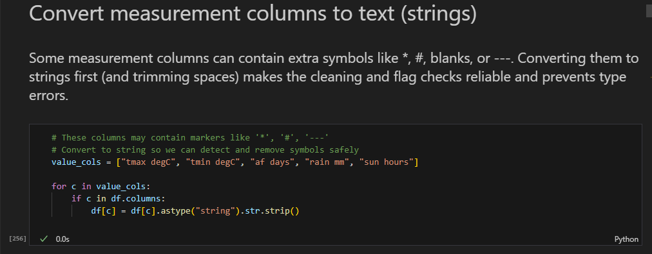
I converted measurement columns to text to safely identify special symbols and avoid data type errors during cleaning.
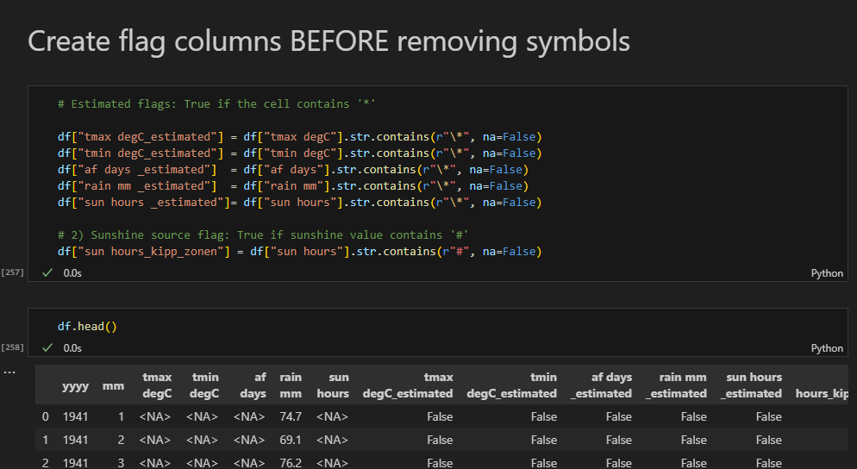
Step 4: Creating Flags for Estimated and Source-Specific Values
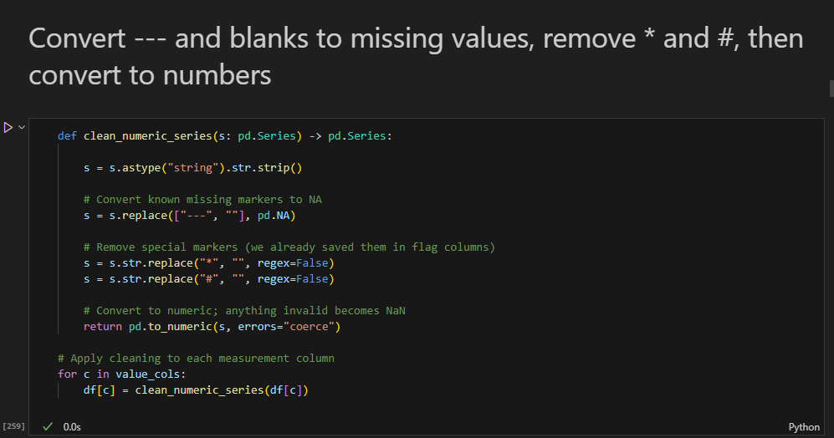
I created flag columns before cleaning to retain information about estimated values and changes in data collection methods.
Step 5: Creating a Proper Monthly Date Variable
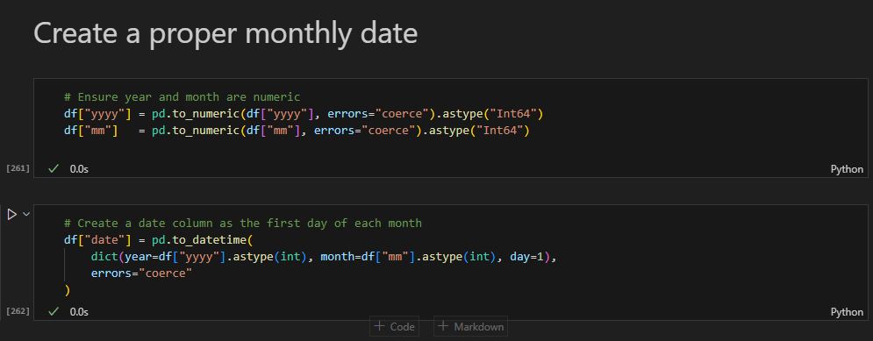
I created a standard monthly date variable to support accurate time-series analysis and forecasting.
Step 6: Creating Derived Metrics for Analysis and Reporting
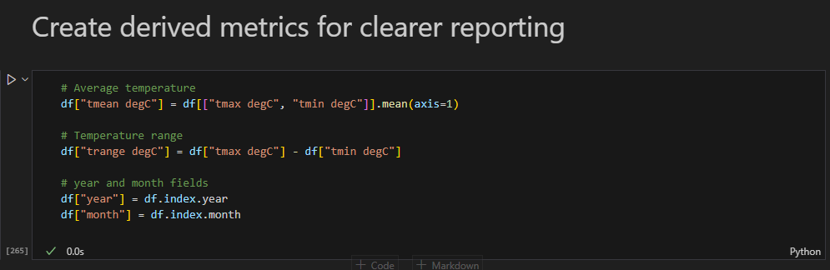
I created derived metrics to summarise temperature behaviour and support clearer trend and seasonal analysis.

Step 7: Data Quality Checks for Missing Values
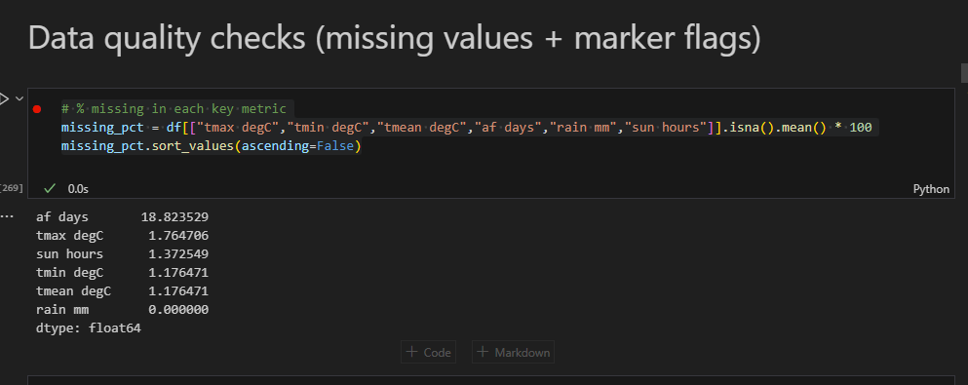
I quantified missing values to assess data quality and identify variables that required cautious interpretation.
Step 8: Interpretation of Sunshine Data Source Flags
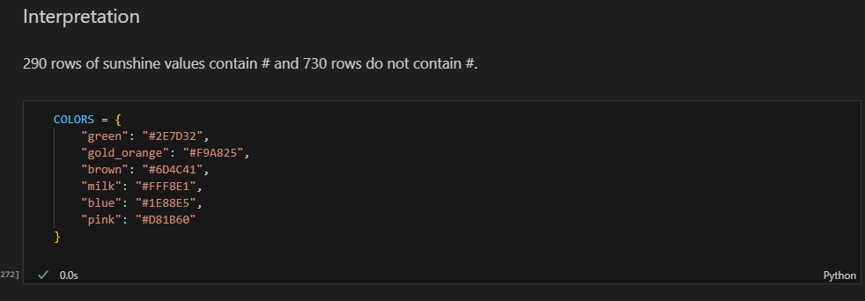
I identified changes in sunshine measurement methods and used consistent visual styling to clearly communicate these differences.

Step 9: Analysing Seasonal Temperature Patterns
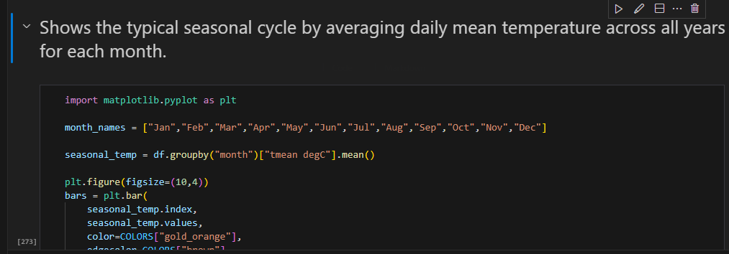
I averaged temperatures by month across all years to clearly show the typical seasonal cycle.

Step 10: Analysing Long-Term Annual Temperature Trends
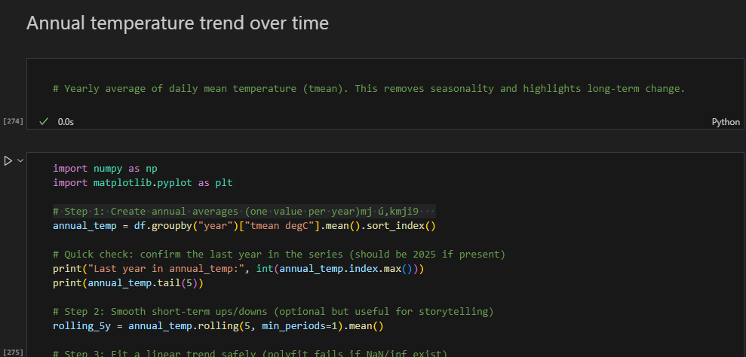
I averaged temperatures by year and applied a rolling mean to clearly highlight long-term trends.
Step 11: Analysing Long-Term Rainfall Trends
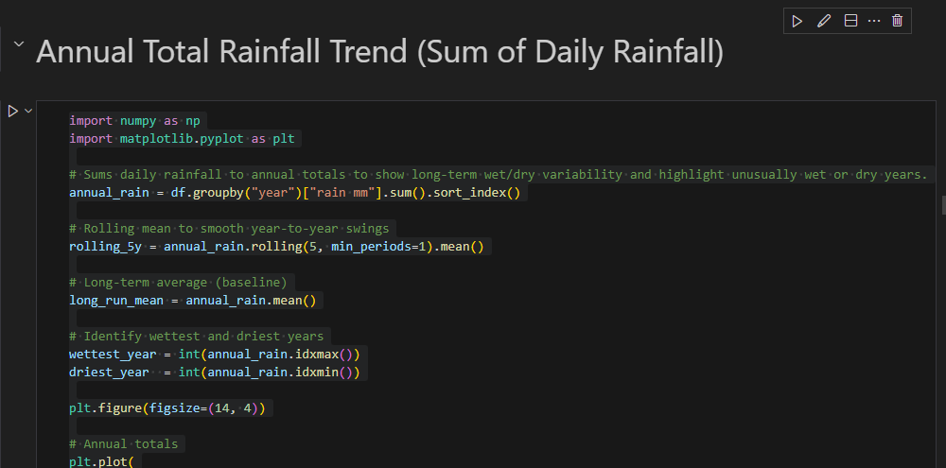
I aggregated rainfall annually and applied a rolling average to understand long-term wet and dry trends.
Step 12: Analysing the Relationship Between Temperature and Sunshine
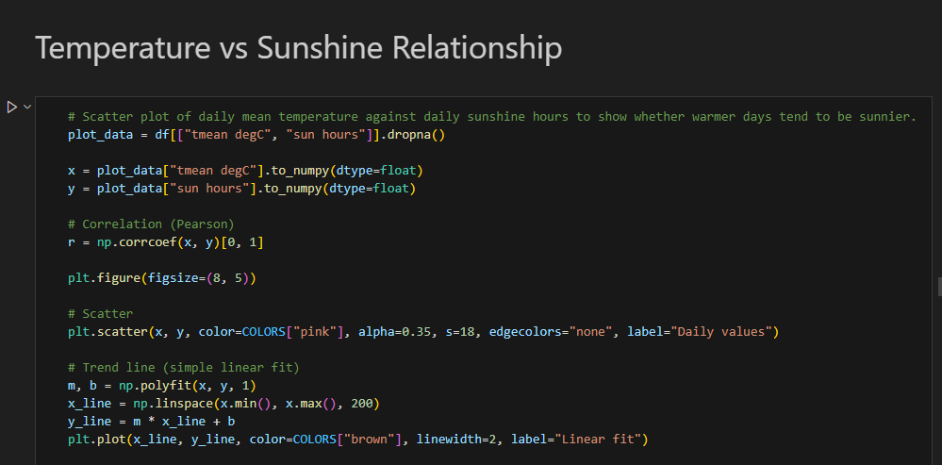
I compared temperature and sunshine using correlation and a trend line to confirm that warmer periods tend to be sunnier.
Step 13: Creating a Simple Seasonal Forecast
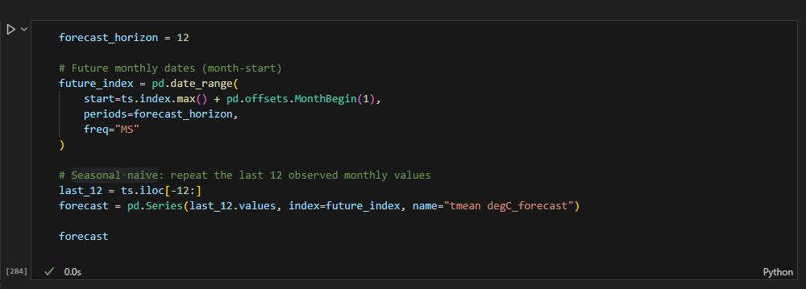
I used a simple seasonal approach by repeating the most recent year of data to produce a transparent short-term forecast.

